* Phone Usage vs. Study Time
  + Who
    - What is your class year?
      * A red and blue circle with a blue circle with white text

        Description automatically generated
    - What is your major?
      * A graph with purple bars

        Description automatically generated with medium confidence
    - What is your sex?
      * A pie chart with different colored circles

        Description automatically generated
  + What
    - On average, how much time a day do you spend on your phone?
      * A pie chart with numbers and a few words

        Description automatically generated with medium confidence
    - On average, how many hours a day do you spend studying?
      * A pie chart with numbers and a few words

        Description automatically generated with medium confidence
  + When
    - When do you use your phone most?
      * A pie chart with text below

        Description automatically generated
    - When do you study the most?
      * A colorful pie chart with text

        Description automatically generated
  + Where
    - Where do you use your phone the most?
      * A pie chart with text below

        Description automatically generated
    - Where do you study the most?
      * A pie chart with colorful circles and text

        Description automatically generated
  + Why
    - Why do you use your phone for the amount of time you do?
      * A pie chart with text on it

        Description automatically generated
    - Why do you study for the amount of time you do?
      * 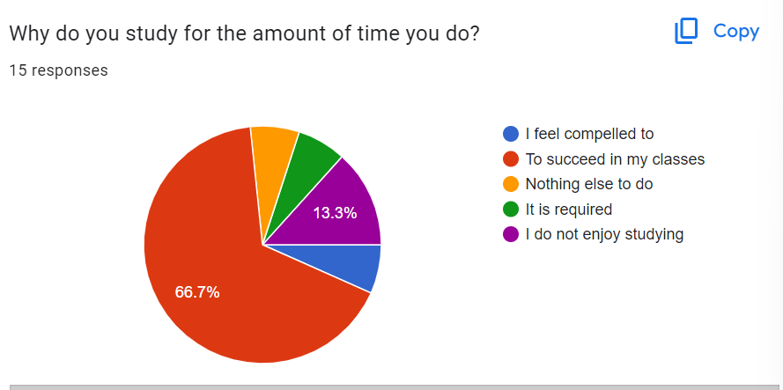
    - Why do you use your phone the most during the time you do?
      * A pie chart with different colored sections

        Description automatically generated
    - Why do you study the most during the time you do?
      * A pie chart with text on it

        Description automatically generated
    - Why do you like to use your phone the most in your favorite area?
      * A pie chart with text

        Description automatically generated
    - Why do you like to study the most in your favorite area?
      * A pie chart with text on it

        Description automatically generated
  + How
    - I sent out my surveys in two different ways to conduct it. I put it into the hackberry discord, and then I sent it out to a couple different individuals. I had let the survey sit for about a week before I grabbed the responses to get the maximum amount of entries (which ended up being 15).
    - I used a function to grab the percentages of each option within each question and used the same function to get each individual percentage for options.
      * The function consisted of numerator/denominator. The numerator was a data frame specific to the question that was being asked, and returned the numerical answer needed to answer the question. The denominator was a general data frame which gave the numerical value of all entries in the survey.
    - I think a possible weakness of my survey was that it was far too long. I tried to see if I could find a correlation between high phone usage and low studying time, however, I did not ebd up seeing any apparent correlation. I believe this was because of the fact that I asked way too many questions so people just started clicking random options.